EshoppingZone

**Synopsis:**

EShoppingZone is an ecommerce website, E**-**commerce is the activity of buying or selling of products on online services or over the Internet. There are two roles one is merchant where he sells the products and other was the customers. Here customers can create account and login to their active account. Users can browse various types of products. Products on this site will be displayed category wise.

This site consists of various types of products like electronics, books, apparel, and personal-care items, etc.

User can browse through the products and gradually add them to his cart. When the user completes adding the necessary items then he clicks checkout which redirects him to the checkout page where the total of the products in the cart is displayed

It also allows users to make payment through various modes like wallet payment and cash on delivery. Users can also update their profile and list their previous orders and transactions.

**Detailed Requirements:**

* User can search for a product without login and access the website.
* User can login with github or with the account with which he registered in the website in order to be able to use the website.
* User can add or remove products from the cart .
* For placing the order user has to login or create the account if he don’t have active account.
* User can update the profile whenever he needs to update.
* User can make wallet payment and also cash on delivery.
* User can view their previous orders and transactions.

**Class Diagram**

**Profile-service**: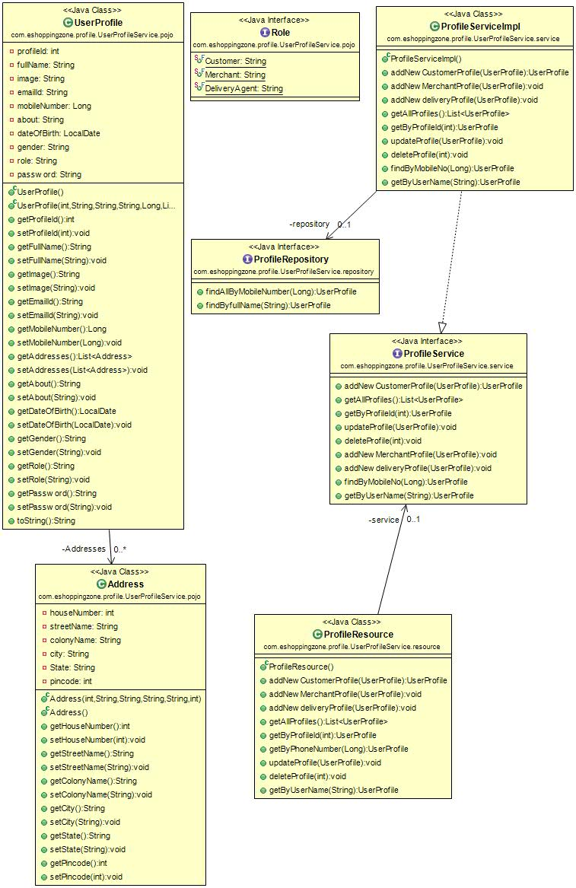

**Product-service**: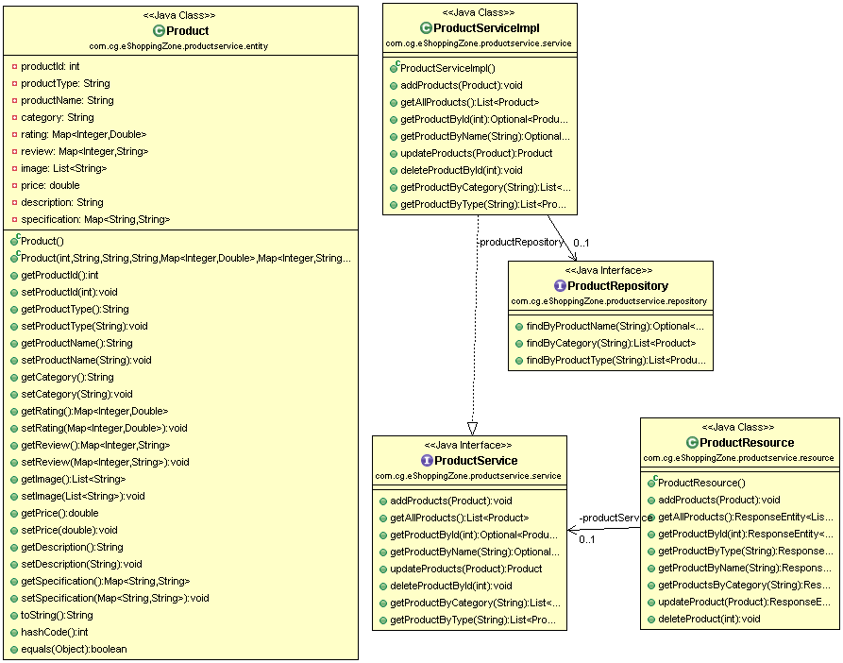

**Cart-service**: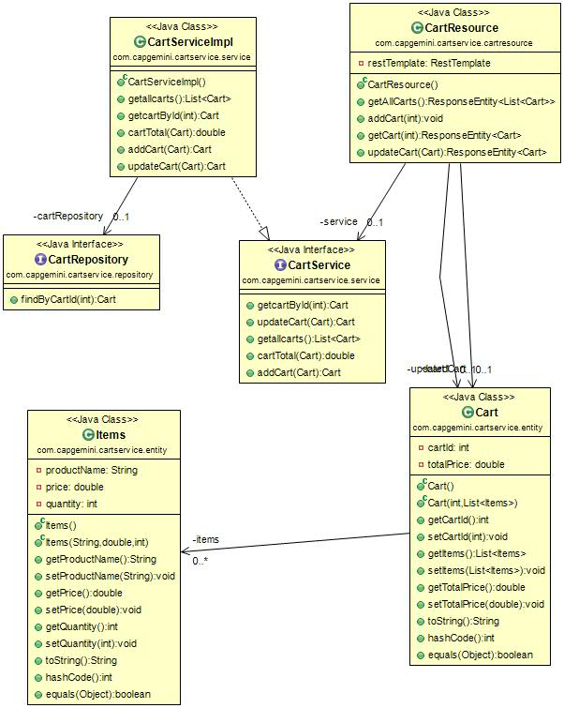

**Order-service**:

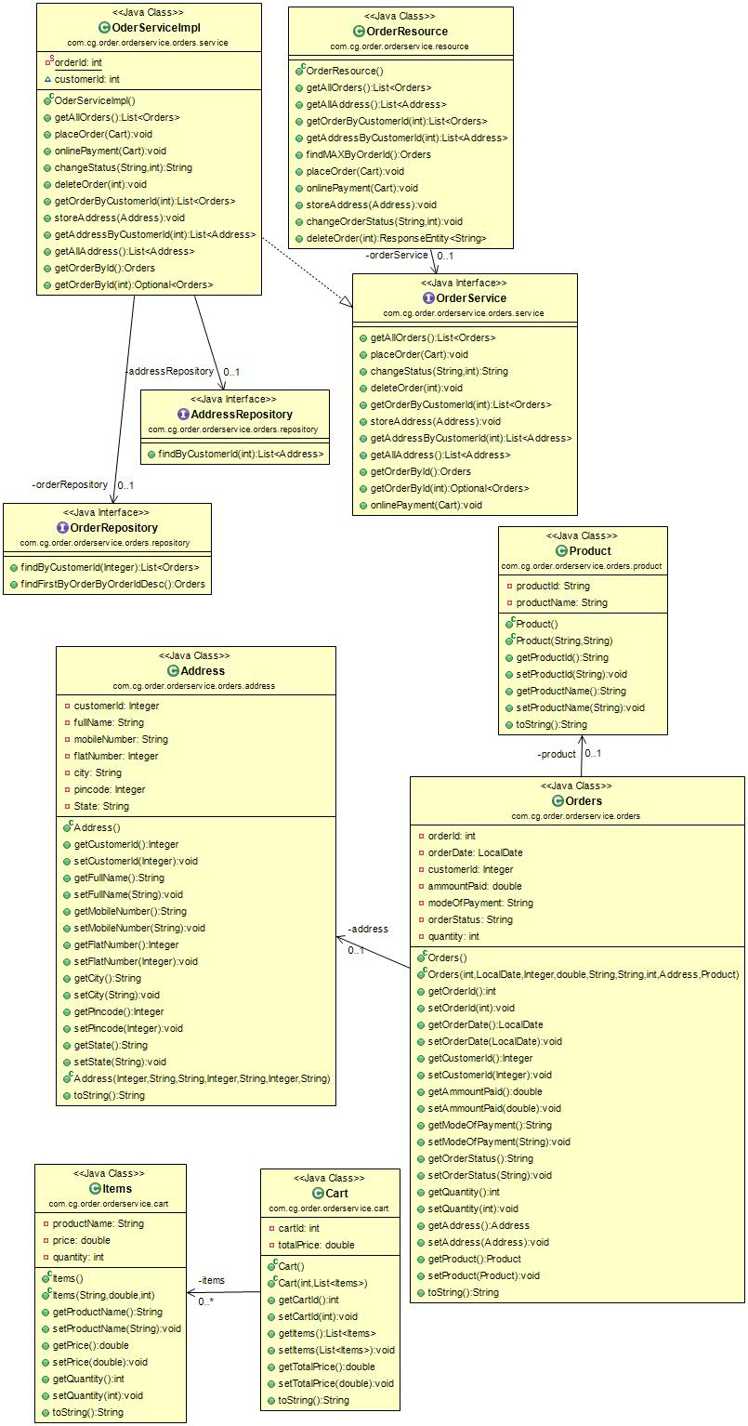

**Wallet-service:**

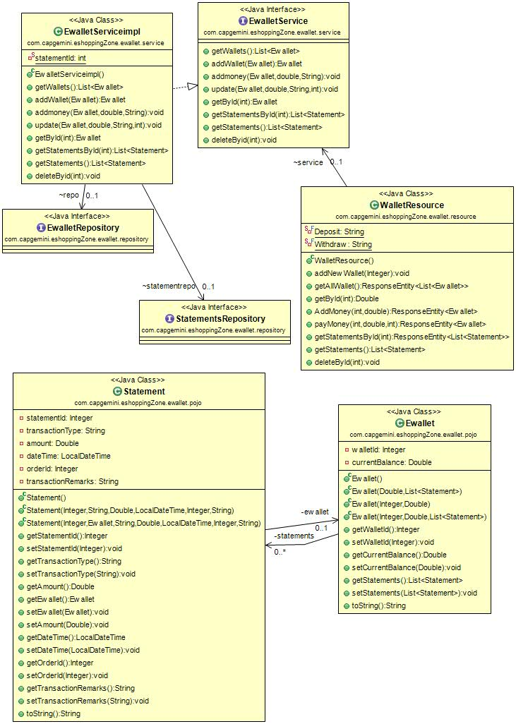

**Website-controller**:

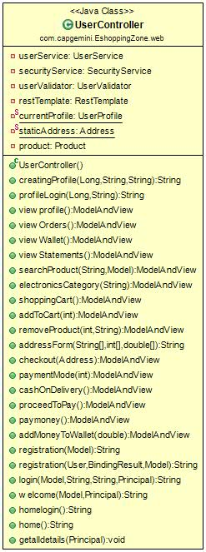

**Use Case Diagram:**

